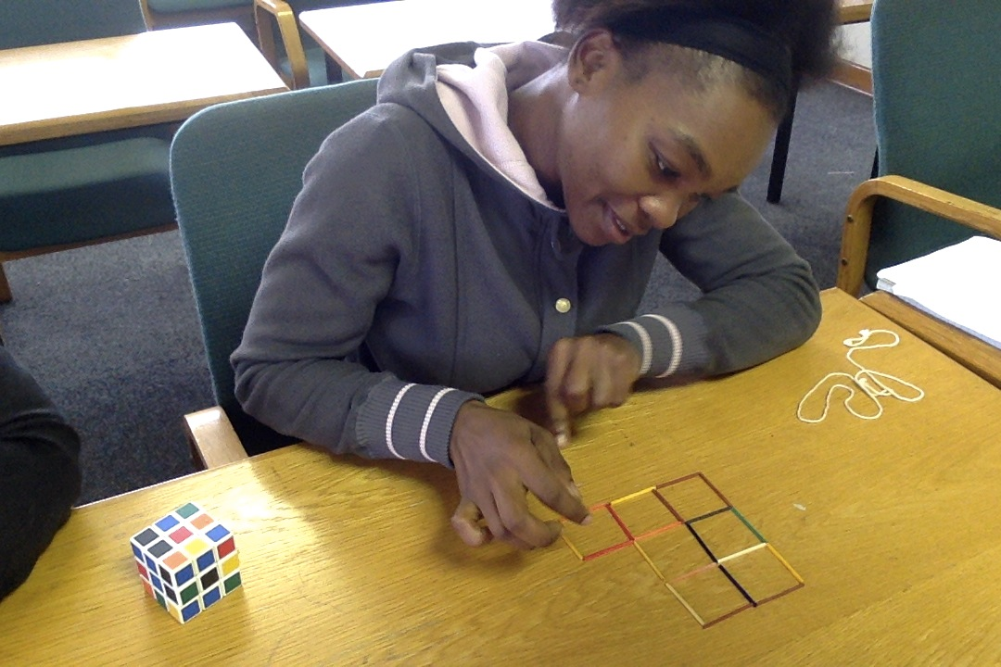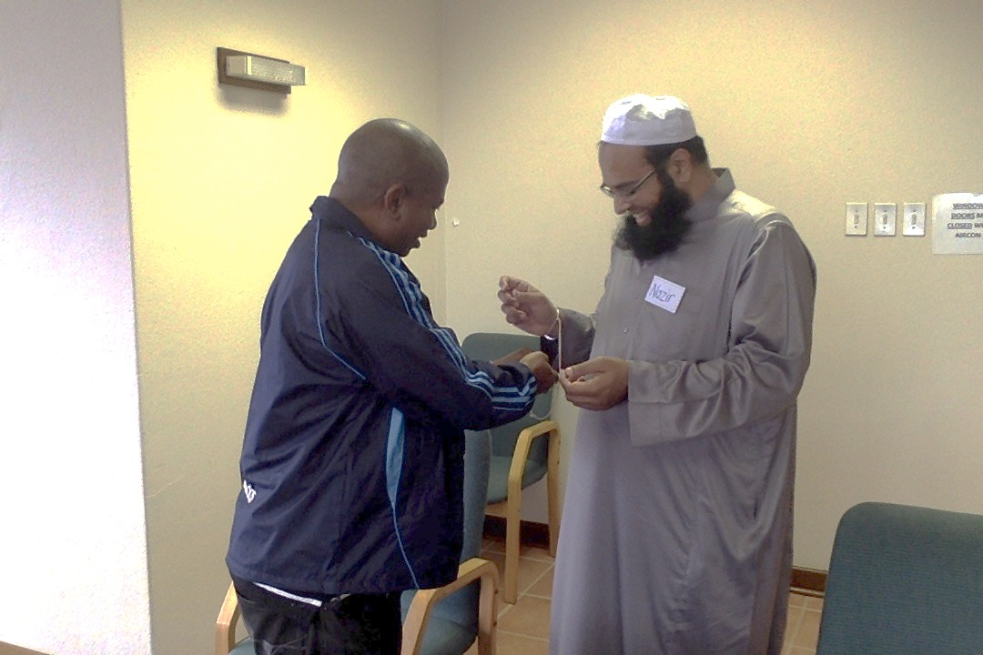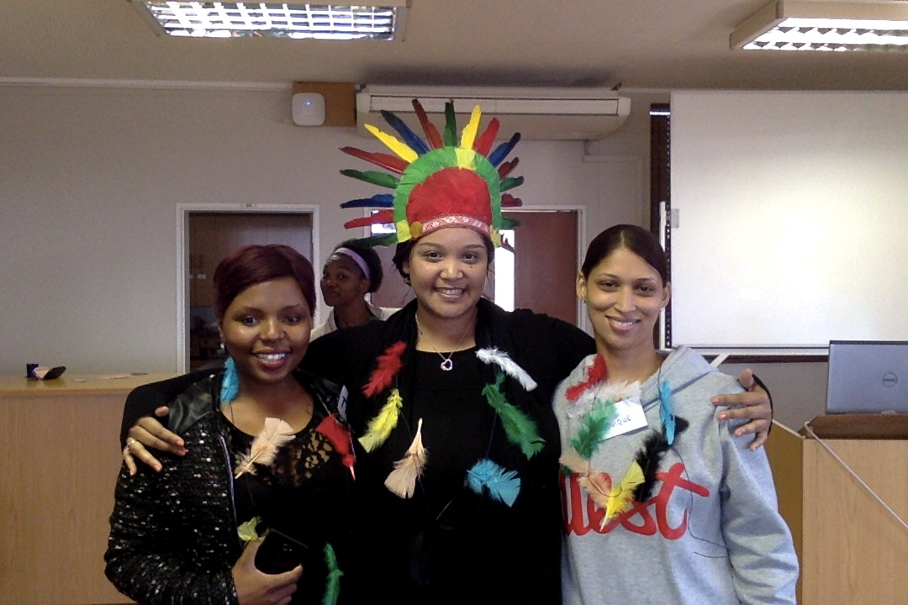

COMMUNITY DEVELOPMENT UNIT – ENGAGEMENT OFFICE

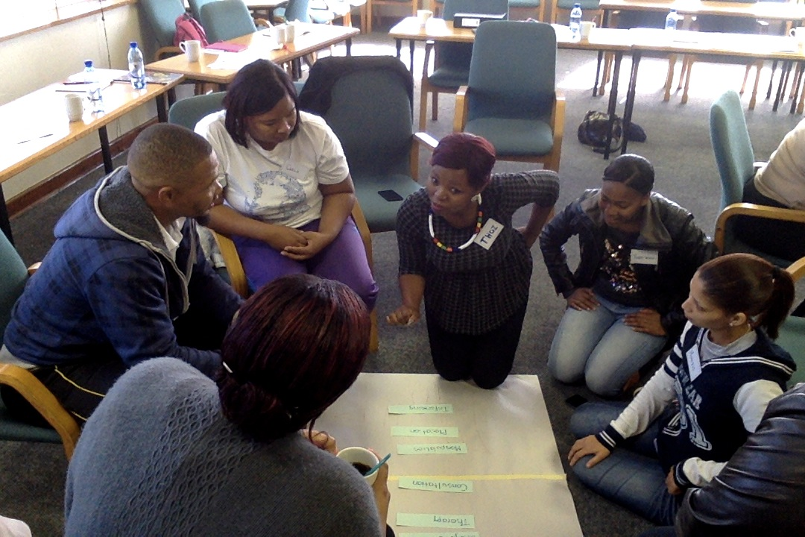

Introduction to Community Development is a 4-day Short Learning Programme (SLP) designed for individuals who have a willingness to uplift the communities they serve.

The SLP is offered at introductory level and delivered in workshop format. Group activities ensure a highly participative process.

The 4-day process provides delegates with an opportunity to explore how they can serve communities more effectively through applying Community Development concepts, values, principles and methods. The SLP is particularly suited to groupings such as Social Workers, non-profit organisations, Community Development Workers (CDWs) and community volunteers.

For more information and/or information about the Community Development Unit’s other offerings please contact **Ms. Debbie Mattheus** (Training Coordinator)

E-mail address: [Debbie.Mattheus@mandela.ac.za](mailto:Debbie.Mattheus@mandela.ac.za)

Telephone 041 504 4005 / Cell: 060 369 9512

For queries related to bookings, registration, payment and certificates please contact **Ms. Saadiqah Pandie** (Admin.)

E-mail address: [Saadiqa.Pandie@mandela.ac.za](mailto:Saadiqa.Pandie@mandela.ac.za)

Telephone: 041 504 3398 / Fax: 041 504 9244

Cost per delegate (2018 prices): R3000

Please contact the course facilitator to arrange a discount should your organisation wish to send a group of 12 delegates or more.

Course Dates: Introduction to Community Development

Course 1: Days 1+2: 12+13 March; Days 3+4: 28+29 March

Course 2: Days 1+2: 3+4 May; Days 3+4: 21+22 May

Course 3: Days 1+2: 11+12 June; Days 3+4: 28+29 June

Course 4: Days 1+2: 12+13 July; Days 3+4: 30+31 July

*Course dates are subject to change.*

TRAINING OPPORTUNITIES - 2018

